

MSc in Computing - Team Project

**DT228A – Advanced Software Development DT228A – Data Analytics**

**TrailSeek - Final Project Report**

**Irfan Ali**

**Pooja Omprakash**

**Vini Vinicious**

**Neel Salvi**

**Shubham Jagtap**

**Sayed Danish Jamil**

**Andrea Curley Damian Gordon Paul Kelly**

Technological University Dublin 17/12/2020

**ABSTRACT**

TrailSeek (Event Application) is a mobile first web application that can be used on mobile phones, designed as a single platform for users to browse through list of events around Dublin scraped from multiple local event websites, college & university websites.

Primary functionality of the application is to display information like event title, image, description, time, date, price and location and sides a platform to search events. Additionally, all registered users get recommendation of events based on the events they browse and the events nearby to the browsed event. This application also acts like a social media networking platform which allows registered users to make friends based on suggestions provided by application using interests and location set by the user. Profile settings can be edited to avail friend suggestions based on interests and location information. Registered user can mark an event as interested or/and going to let his friends know about it.

Technology stack for building our application includes ReactJs, NodeJs, Google Cloud Firestore and Django framework. The application interacts with a persistent database which includes an authentication mechanism. It implements asynchronous communication, create/read and update operation on user profile, data consumption from REST API while respecting code security, data security, design patterns and user experience laws and theories at every phase of project development.

This document covers the entire lifecycle of the project, from the background research, prototype designing to the implementation, testing and user evaluation.

**Declaration**

We hereby declare that the work described in this dissertation is, except where otherwise stated, entirely our own work and has not been submitted as an exercise for a degree at this or any other university.

Signed:

Irfan Ali

Puja Omparkash

Syed Danish Jamil

Shubham jagtap

Neel Salvi

Vini Vinicious

17/12/2019

**Acknowledgements**

We would like to thank our supervisors Andrea Curley, Damian Gordon & Paul Kelly, for their guidance and support through the whole duration of this project. Our weekly catchups helped us to stay on track during the lifecycle of the project.

We would also like to thank all the lecturers of the DT228A course for providing great learning content and guiding us through our career in software development by providing knowledge which was vital to complete our project work.

Last, but not the least, we would like to thank all our family and friends for their constant support and providing us motivation throughout.

**Table of Contents**

1. INTRODUCTION 10
   1. Project overview 10
   2. Project objectives 10
   3. Structure of the document 11
2. BACKGROUND RESEARCH 13
   1. Field Research 14
   2. Market Analysis 16
      1. Target User Analysis 16
      2. Competitor Analysis 25
      3. Trend Analysis 29
      4. Data Source Analysis 31
3. USER SCENARIO 34
   1. User Personas 34
   2. Problems being solved for the target users 39
4. TECHNICAL PROBLEM 41
   1. Technical problems identified in similar existing system 41
   2. Challenges faced during the project development cycle 42
      1. Challenges faced during data capture 42
      2. Challenges faced while TrailSeek development 43
      3. Challenges faced during back-end development 43
      4. Challenges faced during front-end development 44
      5. Challenges faced while designing around user interface 45
      6. Challenges faced after front-end development 46
      7. Challenges faced while Deploying TrailSeek Application 47
      8. Challenges faced using technologies 48
5. TECHNICAL SOLUTION 49

5.1 Approach and Methodologies 49

* 1. System Analysis & Design 51
     1. System Requirements 51
     2. Use Case Diagram 53
     3. UX guidelines and principles 54
     4. User Journeys and Storyboards 55
     5. Wireframes & Medium Fidelity Prototypes 57
     6. Technical Architecture 57
  2. DATA 65
     1. Data Access Methods for Events Data 66
     2. Data Access Methods for User Data 70
     3. Data Collection for Events Data 70
     4. Data Collection for Users Data 72
     5. Data Pre-processing 72
     6. Integrating Django 72

5.3.6. Data Warehousing 72

* + 1. Data Storage 78
    2. Data Privacy 79
  1. Implementation 79
     1. Site Maps 80

5.4.2 Anatomy of Application 83

5.4.3. User Interface 85

5.5 Testing 87

1. USER EVALUATION 93
   1. Research Question 94
   2. Proposed Hypothesis 94
   3. Data Collection for User Evaluation 96
      1. Selected Subjects 97
   4. Data Analysis 99
      1. Analysing the data collected using questionnaire 99
      2. Analysing the data collected through Cognitive walkthrough 100
      3. Analysing the data collected through Think Aloud 101
   5. Findings of evaluation 101
      1. Evaluation iteration 1: 101
      2. Evaluation iteration 2 104

6.5.3 Evaluation iteration 3 107

* + 1. Expert review 111
    2. Evaluation Iteration 4 112
  1. Conclusion of User Evaluation 116

1. PROJECT MANAGEMENT 118
   1. Gantt Chart 118
   2. Ancillary Technologies Used 118
2. LIMITATIONS OF THE SYSTEM 120
3. CONCLUSION 121
4. REFERENCES 124

APPENDICES 124

APPENDIX A 129

APPENDIX B 135

APPENDIX C 142

**Table of Figures**

Figure 1: Report by Conventions 2020 highlighting the reasons behind people attending events 15

Figure 2: "Let’s Celebrate 2017” depicting the number of attendees at live entertainment events in

Republic of Ireland 16

Figure 3 : Gender demographics of 22 participants 17

Figure 4 : Age demographics of 22 participants 18

Figure 5 : Occupation demographics of 22 participants 18

Figure 6 : Technical ability demographics of 22 participants 19

Figure 7 : Interests psychographics of 22 participants 19

Figure 8 : Type of recommendations user expects in an event application by 28 participants 20

Figure 9 : Most used event application by 22 participants 20

Figure 10 : User expectation from an event application by 28 participants 21

Figure 11 : Source of data about an event to 22 participants 22

Figure 12 : Type of devices 28 participants use to find events happening in Dublin 22

Figure 13 : Frequency of attending an event by 22 participants 23

Figure 14 : Time spent on an event application by 22 participants 23

Figure 15 : Lotus blossom technique used for competitor analysis within the team 28

Figure 16 : User Persona 1 34

Figure 17 :User Persona 2 35

Figure 18 : User Persona 3 36

Figure 19 : User Persona 4 36

Figure 20 : User Persona 5 37

Figure 21 : User Persona 6 38

Figure 22 : Iterative model 49

Figure 23 : Agile SCRUM methodology 50

Figure 24 : Use case Diagram for Guest User 53

Figure 25 : Use case Diagram for Registered User 54

Figure 26 : Hook’s Models for TrailSeek 54

Figure 27 : System Architecture 57

Figure 28 : Kubernetes deployment architecture for TrailSeek 58

Figure 29 : Firebase services used for the TrailSeek front end application 58

Figure 30 : Data model for TrailSeek Application 63

Figure 31 : Behavioral flow of TrailSeek-Django application 64

Figure 32 : Flow of scraping of websites 64

Figure 33 : Database Model for TrailSeek Application 65

Figure 34 : Sample robots.txt 67

Figure 35 : Code Snippet of python scripts for Scrapping 71

Figure 36 : Types of Data 72

Figure 37 : Data Warehousing Architecture 73

Figure 38 : Flow of data in Data Staging Area 74

Figure 39 : Flow of loading data to database 75

Figure 40 : Process for recommending similar events 76

Figure 41 : Process for recommending nearby events 76

Figure 42 : Process for suggesting friends 77

Figure 43 : PDCA Cycle 78

Figure 44 : Mind map 80

Figure 45 : James’s journey imposed on TrailSeek site map 81

Figure 46 : Moana’s journey imposed on TrailSeek site map 81

Figure 47 : Kate’s journey imposed on TrailSeek site map 81

Figure 48 : Peter’s journey imposed on TrailSeek site map 82

Figure 49 : Connor’s journey imposed on TrailSeek site map 82

Figure 50 : Mary’s journey imposed on TrailSeek site map 83

Figure 51 : Structure of TrailSeek Front end application 84

Figure 52 : Structure of TrailSeek-Django application 85

Figure 53: Summary for Analysis of Evaluation 1,2 & 3 112

Figure 54 : Performance Report Before Optimization 115

Figure 55: Performance Report After Optimization 116

Figure 56 : Gantt Chart 118

**Table of Tables**

Table 1 : Pros and cons of Eventbrite 25

Table 2 : Pros and cons of Facebook 26

Table 3 : Pros and cons of Vipsy 26

Table 4 : Pros and cons of Meet up 27

Table 5 : Pros and cons of Ticketmaster 27

Table 6 : Comparison of features identified in Eventbrite, Facebook events, Meetup, Ticketmaster and Vipsy 29

Table 7 : Identified websites for data gathering and events availability 33

Table 8 : Functional Requirements 52

Table 9 : Non- Functional Requirements 53

Table 10 : List of researched websites with issues in scraping 69

Table 11 : List of Data sources and retrieval method 70

Table 12 : Test Cases 93

Table 13 : Relationship between data collected and performance metrics 97

Table 14 : Measuring criteria for the usability metrics 99

Table 15 : Percentage scores for performance metrics 99

Table 16 : Percentage scores for performance metrics using cognitive walkthrough 100

Table 17 : Performance metrics obtained through questionnaire (evaluation iteration 1) 101

Table 18 : Performance metrics obtained through cognitive walkthrough (evaluation iteration1) 102

Table 19 : Issues reported in Think aloud technique (evaluation iteration 1) 104

Table 20 : Performance metrics obtained through questionnaire (evaluation iteration 2) 105

Table 21 : Performance metrics obtained through Cognitive walkthrough (evaluation iteration 2). 106 Table 22 : Issues reported in Think aloud technique (evaluation iteration 2) 107

Table 23 : Performance metrics obtained through questionnaire (evaluation iteration 3) 108

Table 24 : Performance metrics obtained through Cognitive walkthrough (evaluation 3) 109

Table 25 : Performance metrics obtained through Cognitive walkthrough (evaluation 3) 110

Table 26 : Issues reported in Think aloud technique (evaluation iteration 3) 110

Table 27 : Issues listed during Expert Reviews 112

Table 28 : Tasks mapped as ‘success’ or ‘Failure' in evaluation iteration 4 114

# INTRODUCTION

## Project overview

TrailSeek (Social Outdoor Application) is a mobile first web application which allow users in exploring various events in Ireland under a range of categories. The main purpose of the TrailSeek application, unlike most similar existing applications, is not only discovering an event of user interest but also find people with similar interests across Country. The idea for this project was born from the need to easily search, find details of Trail and get recommendation of Trails on a single platform and made user more active and fit as well as social.

The core functionalities of this mobile application are listed below:

1. Search for Trails by keyword
2. Browse through various categories of Trails
3. Create and manage a user profile
4. Locate Trails on map
5. Mark Trail as ‘Interested’ and ‘going’
6. Get recommendation of Trails based on location and similarity of an event.
7. Get recommendation of friends based on interests and location of a user.
8. Join the Event
9. Edit and update Event information
10. View List of Trails

## Project objectives

The core objectives and learning outcome of this project are:

* + - Develop a fully functional mobile application
    - Implement social media networking features to enhance users' network
    - Get more experience on mobile application development.
    - Understand the benefit of user-centric approach
    - Learn new technologies such as React-Native, NodeJS and NoSQL Database.
    - Understand the challenges and benefits of data scraping (using APIs and scrapping libraries of python)
    - Understand and learn integration of framework
    - Learn how to manage data storage for mobile application on Firebase.
    - Learn how to maintain code versions in GitHub within the team.
    - Learn to use project management tools like ZenHub to track progress and improve velocity of product development
    - Apply project management skills in combination with the Agile methodology to successfully complete the project

## Structure of the document

1. **Background Research**

This section documents the background research that was done before development of this project. It covers the field research and market analysis carried out to identify the potential target users, data sources, competitors and trends in the market. It also presents the observed trend in the market.

1. **User Scenario**

This section defines the identified user personas, types of user roles that help in defining functionalities of this web application in order to solve the technical problems observed in the existing market.

1. **Technical Problem**

This section describes the technical problems of similar existing system identified during the competitor analysis. It also documents the technical challenges faced during different phases of the project development life cycle.

1. **Technical Solution**

This section describes the technical architecture and components of the application. It also describes system analysis, design and Implementation along with the data flow.

1. **User Evaluation**

This section explains the insights derived from the data obtained during five iterations of user evaluation, carried out in a hybrid approach concurrently with

the implementation of the application. It also outlines the derived research question and proposed hypothesis.

1. **Project Management**

This section elaborates on the methods that were used to keep us user centric & design centric. It also depicts how the usage of different project management tools helped in achieving project goal in the given time.

1. **Limitations of the System**

This section highlights the limitations of the system.

1. **Conclusion**

This section gives some insights about what would have been done differently if the project was repeated and summaries what future works would be necessary.

# BACKGROUND RESEARCH

“*If it's fast and furious that you want, live bands, traditional music and various festivals are literally at every crossroads. If you’re more of a laid-back kind of person, then we're never too far from the tranquil scenery and quaint cafés of the country. Everywhere, Dublin is full of culture and history, and each village has its own story to tell and characters to meet.*” [12]

The theme of the project for building an application is to ensure the wellbeing of a nation's citizens, there were quite a few domains that were shortlisted and researched on, in order to build a system which aims to benefit the society.

Annual report “*Health at a Glance: Europe 2018”,* outlines that the highest mental illness in Europe is observed to be in Ireland, being ranked as three out of 36 countries [35]. Referring to a research work “*Mental Health in Ireland: Awareness and Attitude”* by HSE, it is observed that one out of four attempts to improve their psychological wellness by getting out and including themselves in different exercises, meeting new people to make positive life changes [17].

Then again, all through Dublin City, residents and guests appreciate an all year program of occasions and celebrations that commend one of a kind. It pulls in the absolute greatest names and not least considering the excited crowds, yet in addition as a result of its wide scope of facilities provided to both residential crowds and abroad visitors. Likewise, entertainment is one among the gigantic sectors that is greatly affecting economic development by creating employments and generating tourists.

Taking into consideration the influence of entertainment in people’s life in Dublin and economy of the country, why not develop an event application which allows people to build their network with people of similar interests and love for an event.

Both quantitative and qualitative research methods including focus group interviews, direct observation, analysis of documents and research articles, informal stakeholder interviews, surveys and questionnaire were carried to thoroughly understand the entertainment event domain and draw accurate conclusions about who are the target users, why are they important and what problem can be solved for them.

## 1. User Scenario: The Characters

**1.1 The Target User**

The audience for outdoor hiking and trail exploration is influenced by various factors such as the age, fitness level, trail difficulty, interest in nature exploration, etc. Trail Seek is a platform designed to provide trail information for people who want to explore nature and connect to people by hosting user organised events.

The app is designed to target tourists and locals who are interested in exploring various trails across Ireland. The data collection for target audience was done through stakeholder interviews, surveys and research.

Although research suggests that the mean age of users who are active hikers is 22 and above (Hamonko et al., 2011; Kelley et al., 2016), mobile applications are used by children as young as 4 (Kabali et al., 2015). Although mobile application usage starts at a very early age, nature related activities such as hiking, trail running, trail biking, etc account for only 5.4% out of all the outdoor activities among children between the age of 6-19. This suggests that the primary user of our application who will browse and explore the trials is above the age of 22.

In Ireland, there has always been a demand for trial-based activities, so much so that there is a willingness to travel and pay to access the trails (Kelley et al., 2016) and studies have shown that tourism is also affected positively when the ecosystem around trails is improved (MacLeod, 2017). Since the app also has event hosting capabilities, it can be used as a platform for hosting.

Base on the above research we have concluded that the target audience for our app is:

* Adventurers: People who are interested in adventures and group activity.
* Organizations: Organizations such as a university hosting a hike for freshers.
* Charitable trusts: Hosting a fundraising outdoor event.
* Tourists: Introduce the city to tourists who are looking for an outdoor adventure. and at the same time interact with the locals.
* Age group 22 and above.

User Personas :

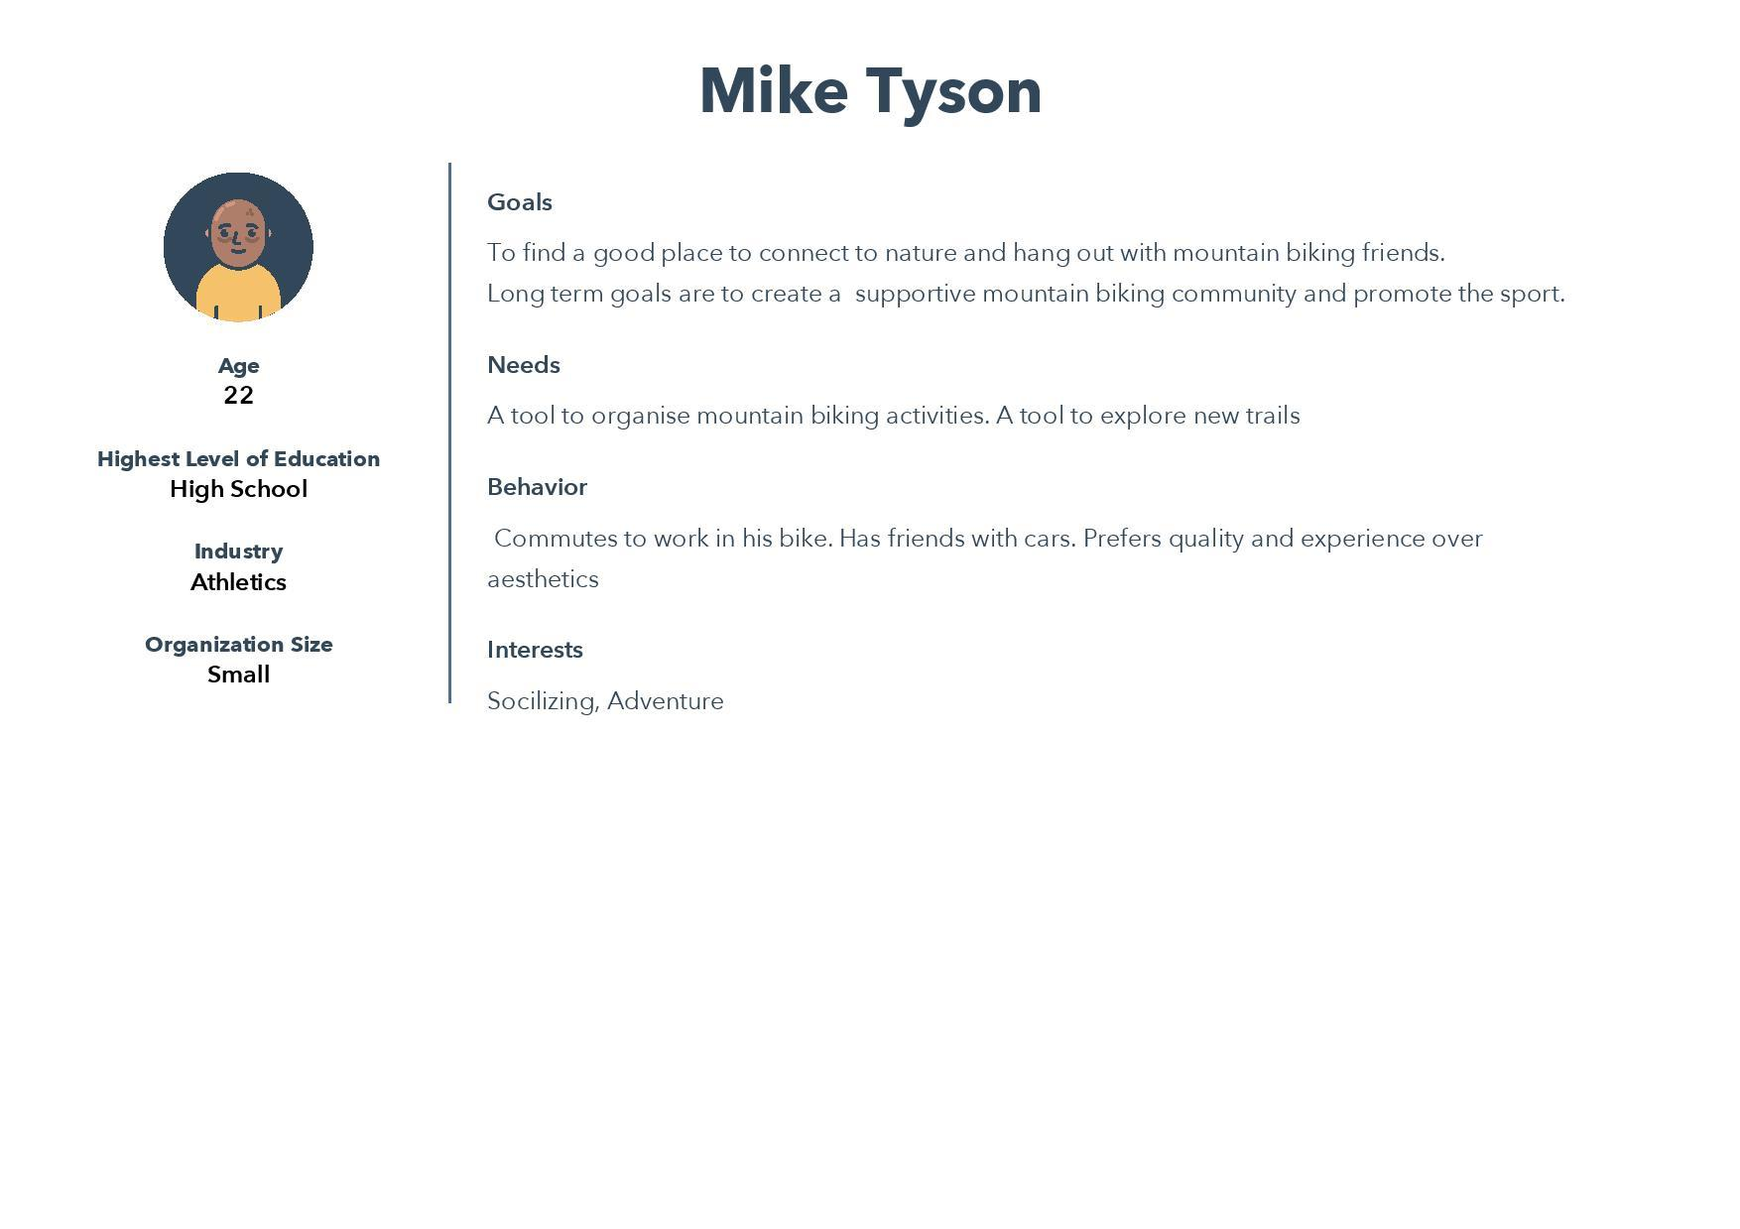

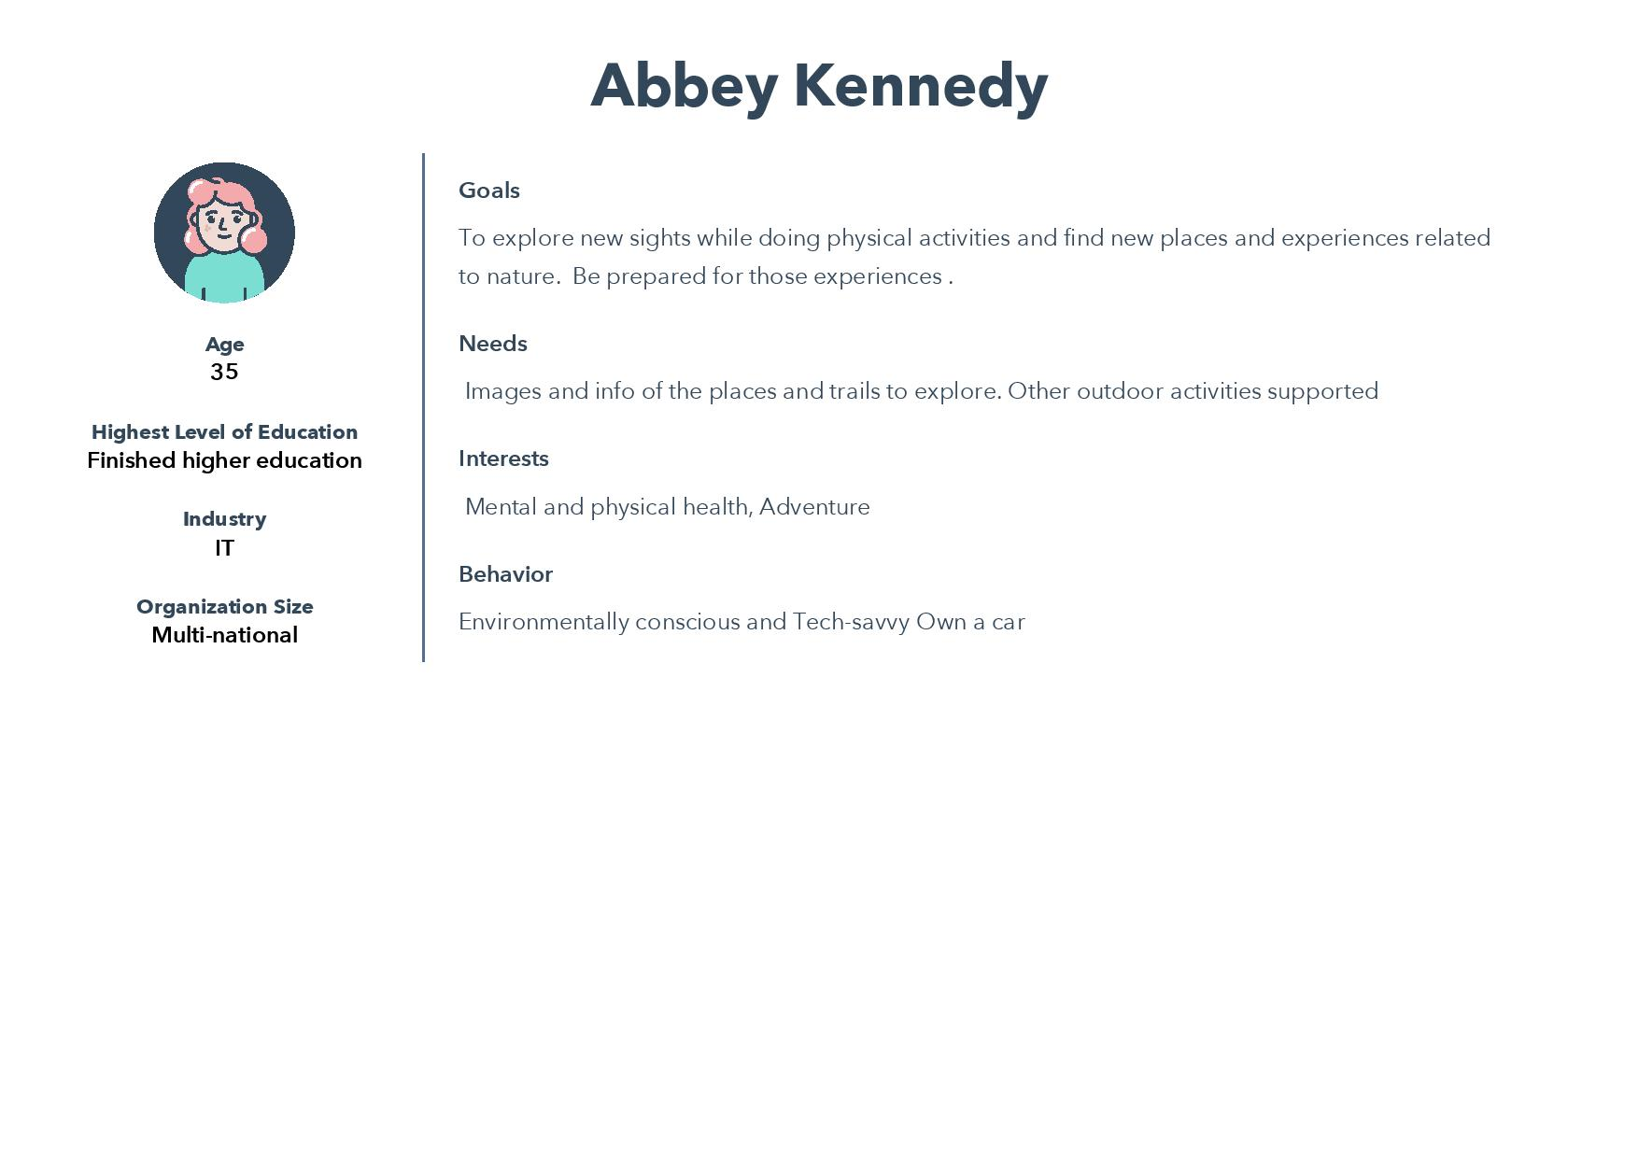

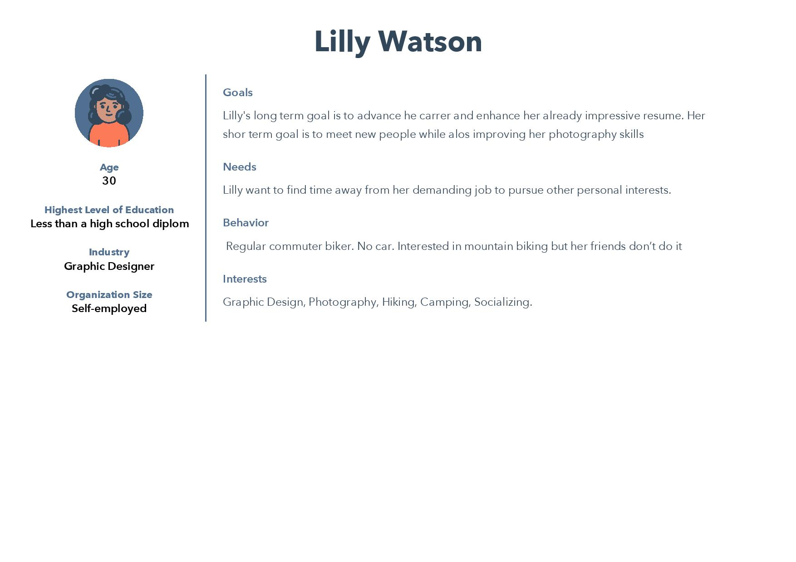

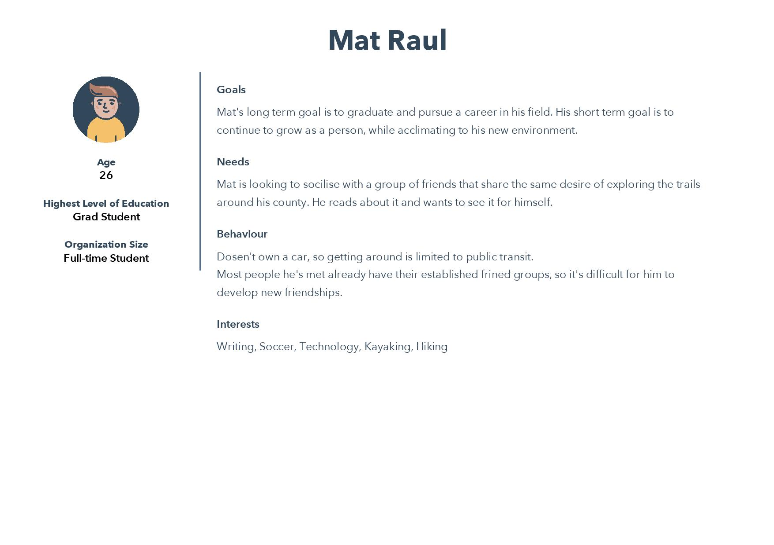

**1.2 The importance of Target Users**

A survey was conducted to gauge the interest of the target audience of our proposed system.

Link to the survey: <https://docs.google.com/spreadsheets/d/1XYTy-t_tKd2iNrYW27kAk2iQU1_N5u9RPXAHy3PvLaI/edit?usp=sharing>

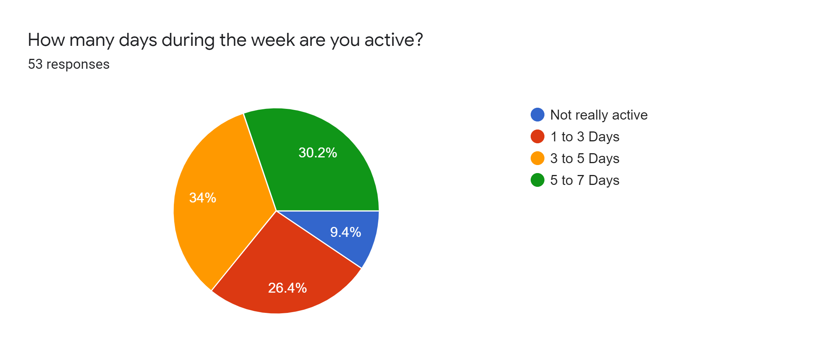

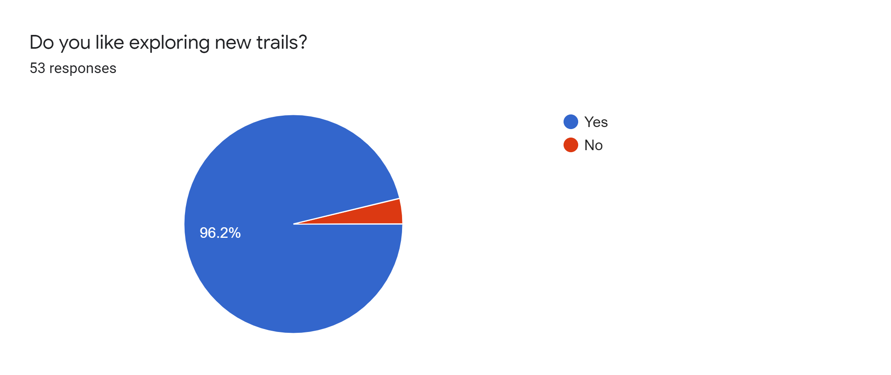

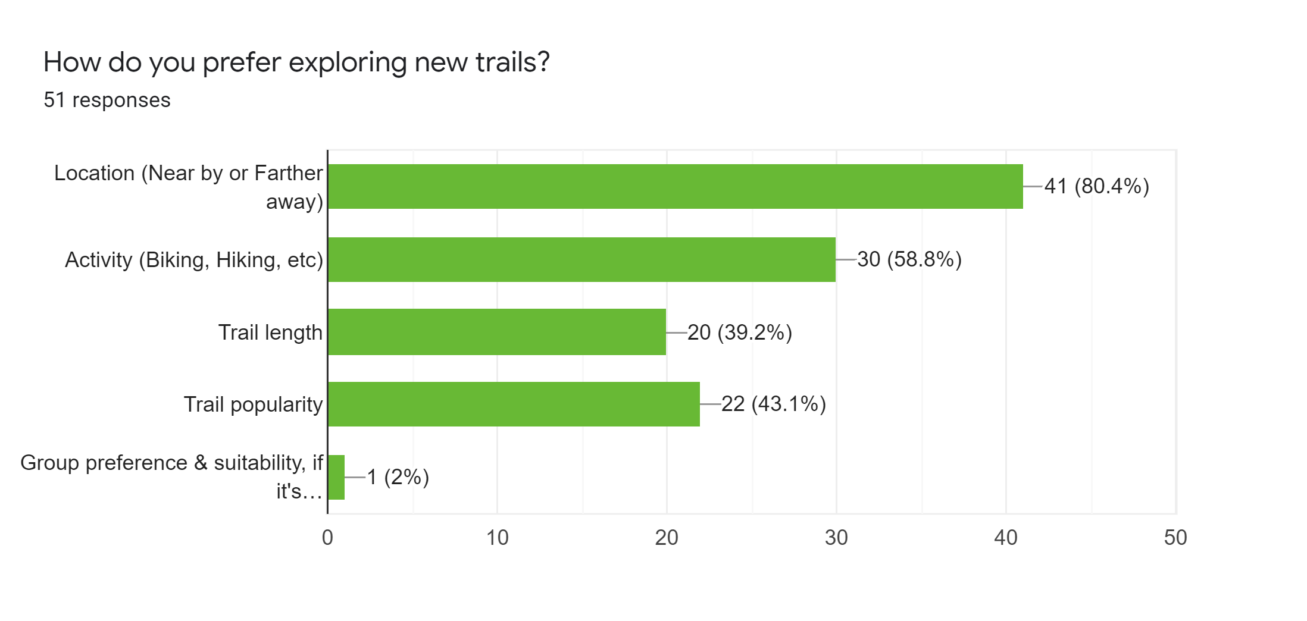

Responses from the survey suggested that most of the people were active for more than 3 day a week and there was a significant interest in trail exploration. These results were expected as there are applications out there which meet these demands.

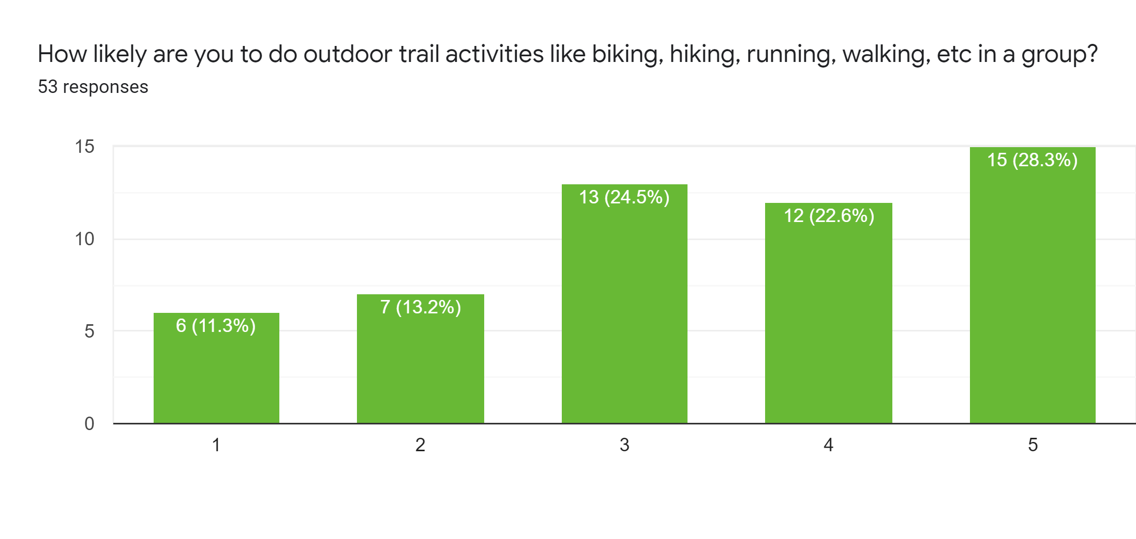

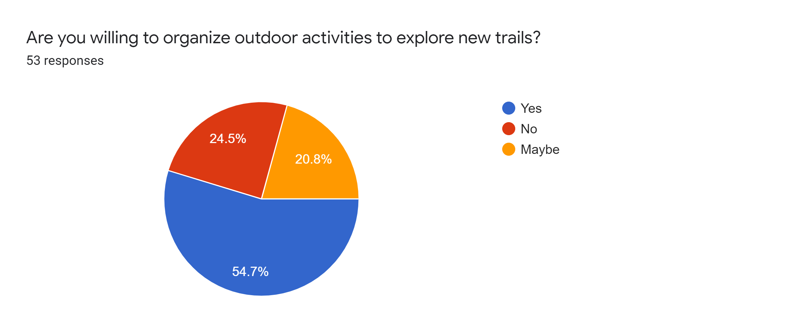

The important factor for us here is the fact that there is an interest in group activities and willingness to host outdoor activities which is one of the core components of our proposed system i.e Events.

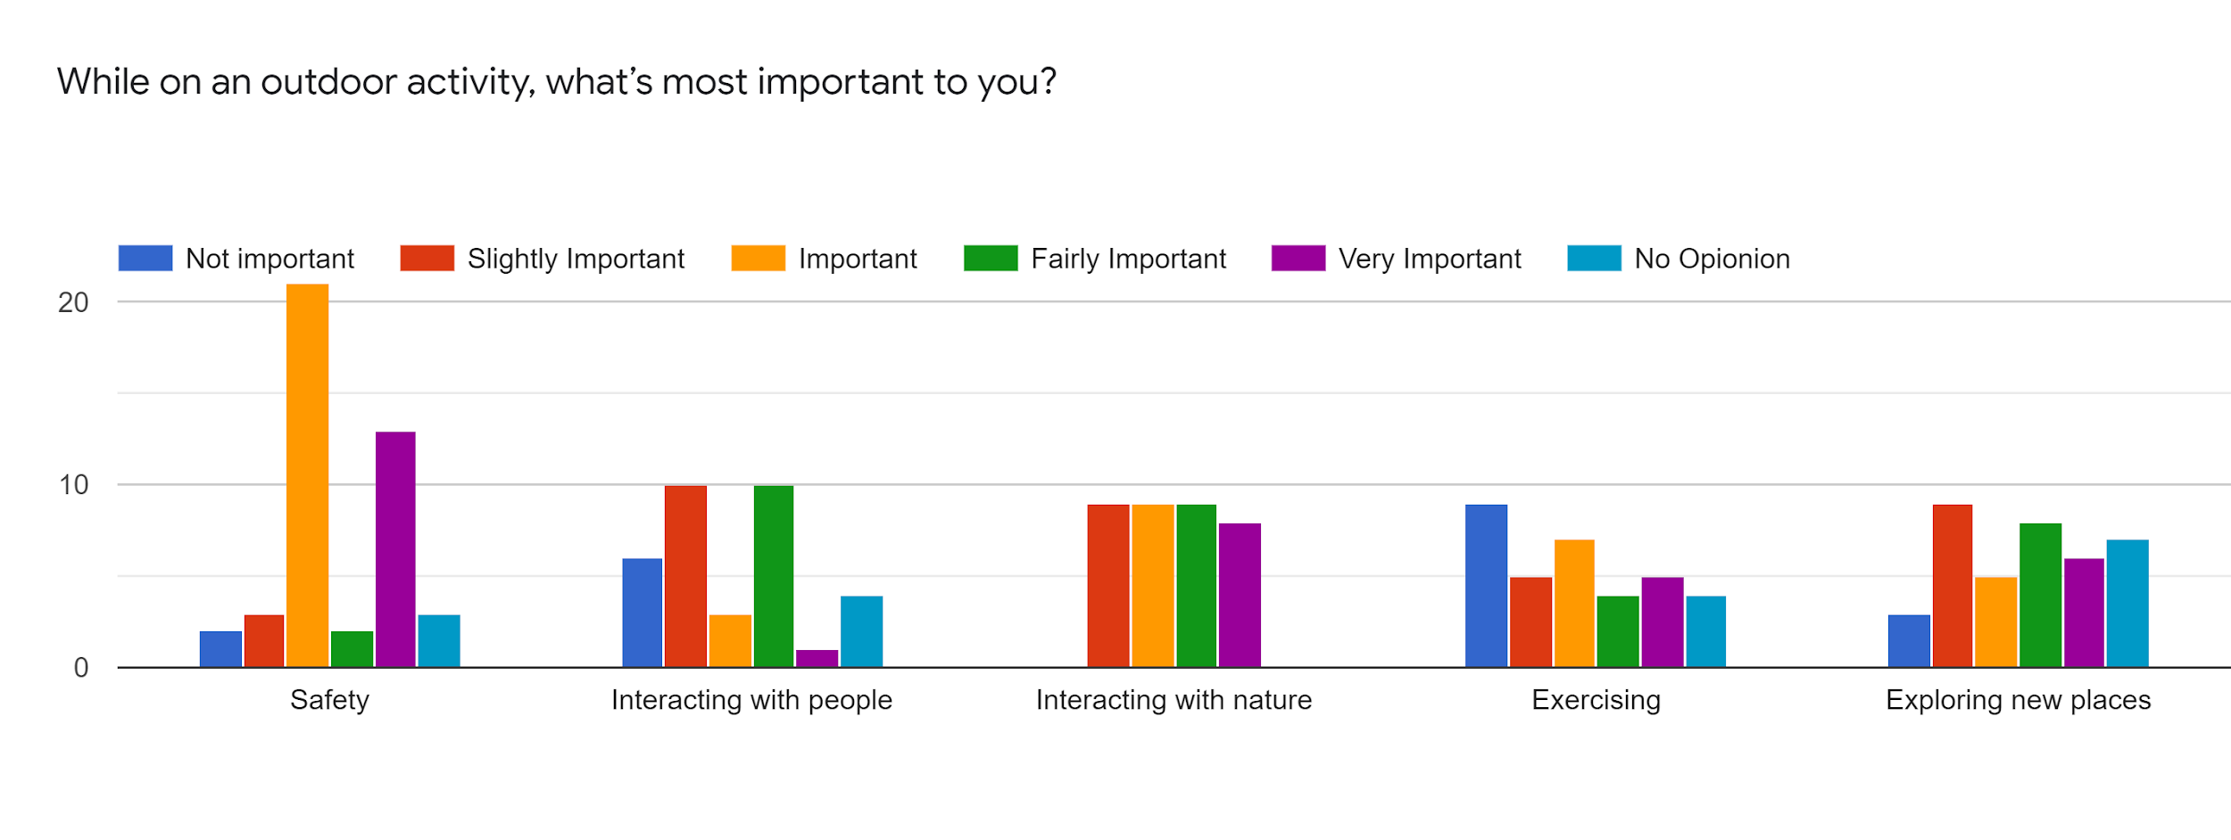

Here we got a gauge of potential features and additional functionalities that could be added in our application. For eg. An importance in exercising suggests a potential of adding an exercise summary at the end of a trail.

1.3 The problems solved for the user

The above data makes it clear that there is a demand for trail exploration in a group environment. Our platform aims to solve that demand by having trail exploration smoothly integrated into group events.

Choosing a mobile application instead of a responsive website has significant advantages. There is a more streamlined access to the device's sensors like GPS. Studies have shown that upto an hour is spent on mobile applications alone each day (Bohmer et al., n.d.) and having a native mobile application typically gives a better user experience (Charland & Leroux, 2011).

## 2. Technical Problem: The Setting

The system exists to allow users to browse, host and join outdoor activities and group events such as hiking, trekking and cycling. The main functionality of the application consists in displaying a list of trails, activities and group events to the users, with the assistance of a recommendation system that takes into account user’s historical data, interests and other activity data such as feedback given to activities and group events attended.

The main functionalities of this application are:

1. Display list of trails near you, popular trails and trails based on activity type.
2. Allow users to search for trails.
3. Host user: Create/edit/delete events on a trail.
4. Participant user: Join/disjoin events.
5. Recommend trails.
6. Feedback on trails.
7. Create/edit user profile.

Other functionalities:

* Weather information on the trail location.
* COVID information on the trail location.

Future Scope:

1. Tracking user’s location while attending an activity
2. Provide user with the event history summary
3. Send users a reminder about the registered event.
4. Provide exercise summary like (calories burnt, no. of steps) while attending group activity.
5. Send SOS alert in case of emergency.

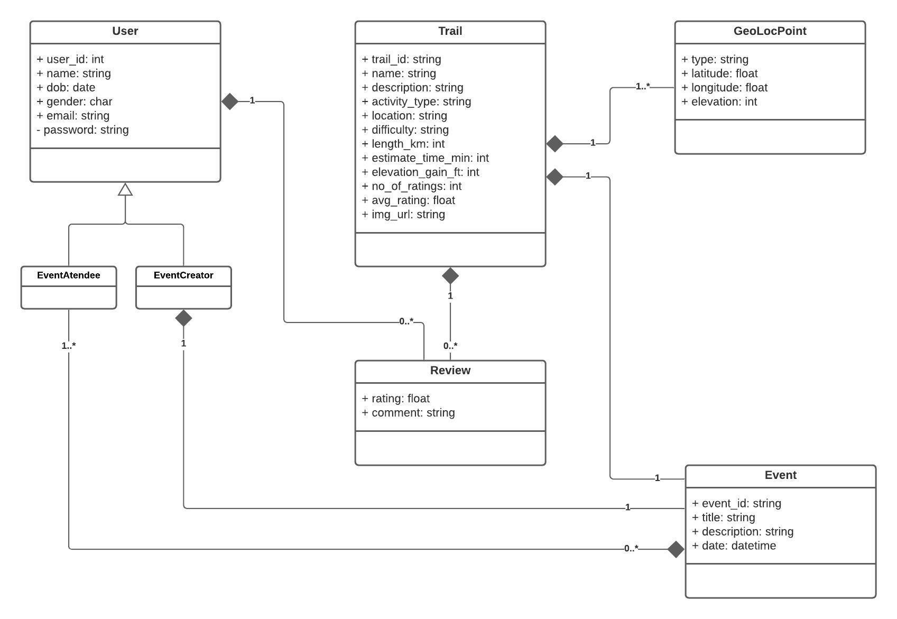Figure X: Class Diagram

**● Can you review other existing systems or products that address this problem? (how do they meet or fail to meet the needs of your target users)**

## 3. Technical Solution: The Plot

### 3.1 Use Case Diagram

The below use case diagram explains the entire end to end application functionality for the user.

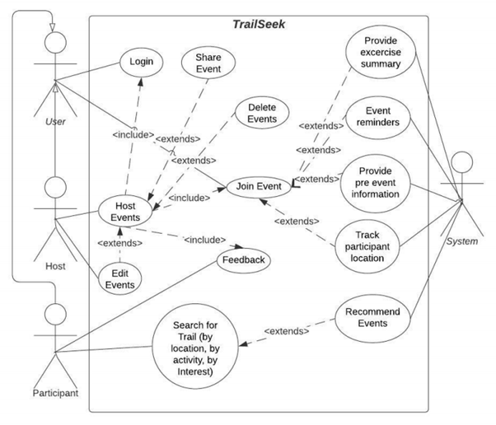

### 3.2 Architecture

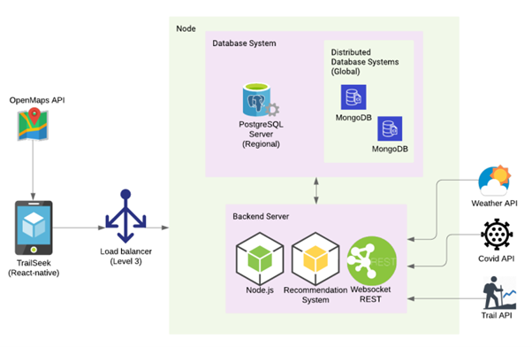

Since the app is to be used primarily for hosting outdoor activities, it would be advantageous to have the end point be a mobile app. It will give the developers the freedom to access some of the native functionalities of a smartphone and it would be more portable and easier to use for the user.

Thus, we have selected React-Native for the front-end. It’s cross platform support which means we can target both Android and iOS users and since it uses JavaScript, we can have one language for the front end and the back end. Redux will be used for state management.

### 3.3 Frontend

Card sorting was performed online to get a general idea of how the users feel on how the flow of the app should be in general. Out of the five participants, three gave us valid data but it was enough to get a general idea of the sitemap. Link to the study: <https://app.uxtweak.com/cardsort/results/1ZuWXIcjnxtqmsU3opGFs/EUi77MhRFg5WbnMej0VOe>.

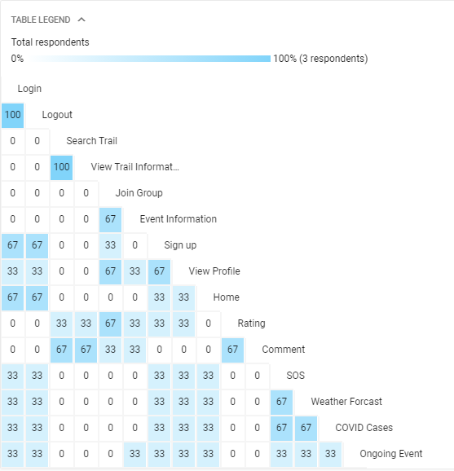

*Figure A: Similarity matrix of the car sorting.*

The site map that was generated from the similarity matrix produced by the card sorting.

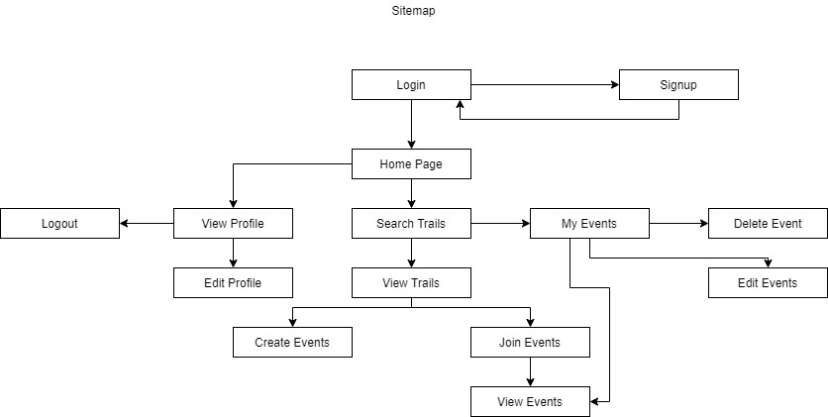

*Figure B: Sitemap*

But since we are developing a mobile application, the sitemap cannot be directly translated into a final product. React native provides a module for navigation within an application called react navigation. There are 3 main types that it provides which are:

1. Stack Navigation - Pages are stacked on top of each other and automatically get a back button at the header.
2. Bottom Tab Navigator - Bottom tabs are provided and are available to the user at all times.
3. Drawer Navigation - A side drawer which is hidden and can be slid out, is provided to the user which has various options the user can choose from.

We went with a hybrid approach between Stack and Bottom tab navigator for 2 reasons. Firstly, Stack navigation provides a good experience when dealing with pages of the same category and bottom tab navigation provides a clear distinction for the users about the different functionality of the application. Secondly, other competing applications have a similar approach with the app navigation so following the Jacob’s law of the UX (Yablonski, n.d.), we wanted the user to feel some familiarity.

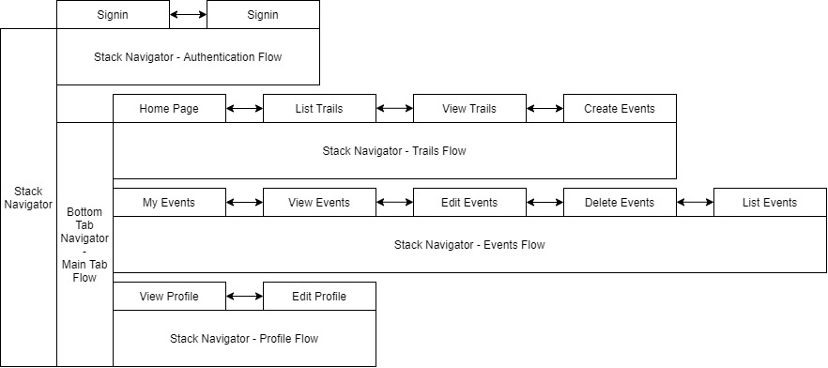

Figure C: Application navigation stack

The above forms a base for our navigation stack but is flexible enough to accommodate various functionalities. It is possible to switch between various stack navigators as needed for eg. It is possible to jump from Create Event and List events.

Low fidelity prototyping:

Some paper mockups were produced to get a general judgement for the application..

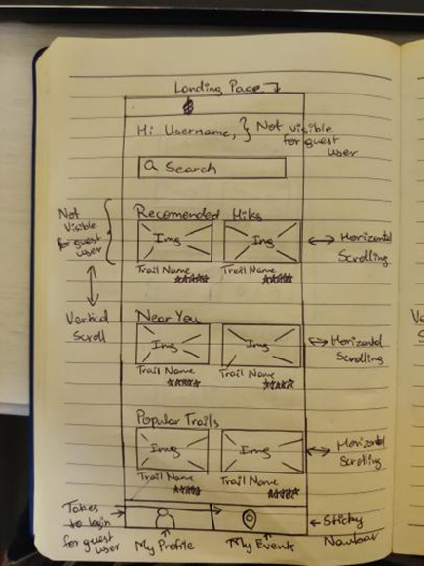

*Figure A: Main Page*

After the user login, the user lands on the main page where the user is welcome and given option to search trails along with list of trails near the user, popular trails and recommended trails.

At the bottom of the page user has the option to edit his/her profile and see list of events he/she is going to attend.

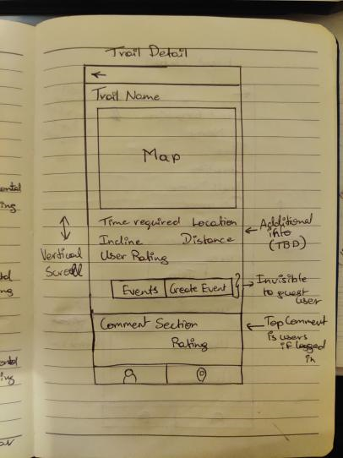

*Figure B: Trail’s Detail Page*

Once the user clicks on a particular trail, he/she will be displayed trails information like name, description, estimated time, difficulty, elevation gain, average rating, distance, trail on map and the user will be given the option to view the events happening on the trail or create an event for the group activity.

Registered users can also rate and comment trails.

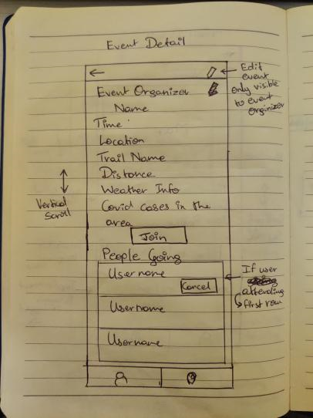

*Figure C: Event Detail Page*

If the user clicks on the event button, he/she will be shown information about the event like event organizer name, time, location, weather info and covid cases in that location along with a list of users attending the event and he/she can join the event by clicking on the join button.

Implemented high fidelity diagram:

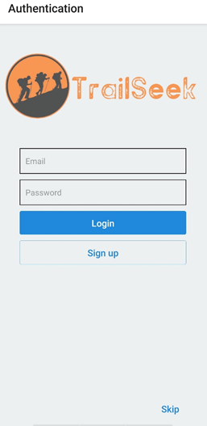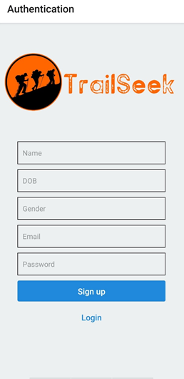

Figure D: Login and Signup Page

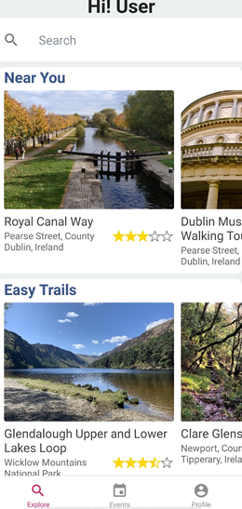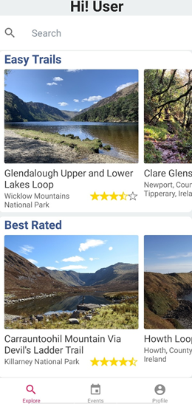

*Figure E: Main Page*

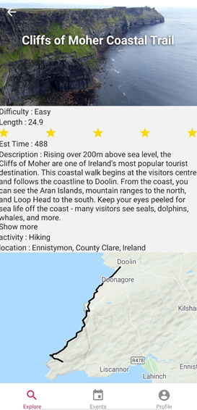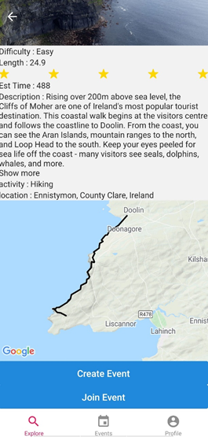

*Figure F: Trail page*

### 3.4 Backend

Our stack consists of various technologies within the JavaScript ecosystem. Since JavaScript is supported in both client-side and server-side, it holds several advantages over choosing different languages. According to the 2019 Stack Overflow Development Survey, JavaScript was elected the most generally used programming language, ReactJS the second most prevalent Web framework, and NodeJS the most popular run-time environment for server-side applications. In line with this survey, we have chosen a mix of a MERN (MongoDB, ExpressJS, ReactJS, and NodeJS) and PERN (PostgreSQL, ExpressJS, ReactJS, and NodeJS) stack for our project.

Due to many of its technologies being very widespread, the MERN stack is one of the most common stacks on the application development world and has JavaScript at the core of every item. The PERN stack, on the other hand, uses PostgreSQL instead of MongoDB and has been gaining momentum due to its support for an object-relational database system. As a variation of ReactJS and to accomplish mobile compatibility, we will use React Native in the frontend context.

**NodeJS**

According to NodeJS website, it is "*an asynchronous event-driven JavaScript run-time, designed to build scalable network applications*" (https://nodejs.org/en/about/). NodeJS is based on Google's V8 engine, which was originally developed for Google Chrome, and it is used in this project to run JavaScript code outside the browser and for server-side scripting. Because of its single single-threaded design, NodeJS is aimed to optimize throughput and scalability (https://dl.acm.org/doi/book/10.5555/3126361). Upon requests, no new thread needs to be created, making it dead-locking free.

**ExpressJS**

ExpressJS is a web framework for NodeJS, which is used to create a RESTful interface based on the HTTP protocol and its methods such as GET, POST, PUT and DELETE (Porter et. al, 2019).

### 3.5 The Data

**Data Sources**

We found different websites to gather trail data but most of the websites were unable to provide a list of geo location coordinates. Few websites which provided a list of geo location coordinates had very limited data and that limited data was already scraped from AllTrails website. So we decided to use the AllTrails website to collect all of the required data. Also, the weather and Covid data will be fetched using API.

**Data Access Method**

|  |  |
| --- | --- |
| Dataset | Data Extraction |
| AllTrails.com | Web Scraping |
| Weather-API | API |
| COVID19 HPSC Ireland | API |

**Data Collection**

For data collection, web scraping tools such as Octoparse, ParseHub, Web-Harvy were used which extracts data directly from a website to a structured CSV Format. The tools were used because of its ease and rapid functionality of data extraction. The data which the tool couldn’t extract was extracted by writing Python code using the ‘BeautifulSoup’ library.

**Workflow for data extraction**

1. For web scraping using the tool, the url from which the data needs to be extracted is entered in the scraper tool, after which the tool will automatically inspect HTML tags and div tags and data will get extracted in CSV or JSON Format.
2. Features like image extraction were extracted by writing Python code.
3. Once the data was retrieved, it was merged, cleaned and formatted.
4. The final pre-processed data was dumb into the database.

**Data Storage**

For data storage, two database systems are chosen. PostgreSQL will be employed to persist data that requires high consistency (login and user details), while MongoDB will handle data that presumes eventual consistency (activities, group events, trails, user profile pictures and user location) in a distributed master-slave model.

## 4. Evaluation: The Reviews

SUCCESS STATEMENT FOR OUR SYSTEM

Cognitive walk-through method is used to evaluate TrailSeek. Using cognitive walk-through success rate, user satisfaction and security of the application can be enhanced based on following points. The cognitive walkthrough is a technique for assessing the design of a user interface, with good focus on how well exploratory learning is facilitated by the interface, i.e. first-time use without formal training (Rieman J, Franzke M, 1995).

1. Will application users experience the best possible way to find and/or build trail events?
2. Will the application be self-evident?
3. Will the user associate the right action with the result they expect to accomplish?
4. If the correct action is carried out, will the user see that progress is being made towards their desired outcome?

EXPERIMENTAL METHOD FOR EVALUATION

The overall evaluation design comprises of following phases:

1. Evaluating the product.
2. TrailSeek comparison with other similar applications.
3. Technology choices and their evaluation.
4. Analysing the results.
5. Success rate and error rate.
6. User impact on various performed tasks.
7. Success rate of TrailSeek.

EVALUATING THE PRODUCT

The experiment will be conducted allowing different types of users to use the product built. To accomplish this, the users will be approached in different environments like community parks, outdoor grounds, fitness clubs and neighbourhood areas in order to cover a variety of users. And, as mentioned earlier, Cognitive walkthrough Technique will be used to conduct the experiment with questionnaire methodology. Prerequisites will be set and considered for conducting the experiment by designing a set of tasks for the users in the form of test cases and guidelines will be provided for the same.

TRAILSEEK COMPARISON WITH SIMILAR PRODUCTS : Baseline model

The baseline model considered for our evaluation are apps such as AllTrails, Komoot and ViewRanger. While comparing with the baseline model apps we found functionalities and activities that are provided by TrailSeek like joining or hosting events, track participants and weather information, are missing in the similar applications.

DERIVING INSIGHTS FROM ANALYSIS:

When we have addressed test questions, gathered and evaluated user data, we must have a clear understanding of what issues could drive a user away from the product in order to be able to fix them.

SUCCESS RATE VERSUS ERROR RATE MATRICS:

User tasks are usually calculated after a user has attempted a task or monitored during a user's application session during usability testing. Typical user task metrics that we will utilize:

**Task Success Rate**: The percentage of users who successfully complete a task. This would be the most common performance metric that represents how successful users are when performing tasks, where a clearly specified target or end point (e.g. login, register, attend an event, etc.) is necessary for the task to calculate the success rate.

**Error Rate**: The percentage of users who made a mistake during a task (e.g. clicking the wrong button, incorrect information etc.).

**Task Completion Time or Time on Task** – The time it takes users to complete a task (mins / secs). Generally, the smaller time-on-task metric, the better user experience.. Most common way to measure Time on task is to notice the average time spent on each task.

**Ease of completion**:The ease with which a job can be accomplished by users.

## 5. Conclusion: The Plan (500 words approx.)

● What is your project management strategy?

● What are the biggest challenges you are currently facing?

● How will you use the time remaining to achieve a successful outcome?

PROJECT MANAGEMENT STRATEGY:

Agile methodology was used for strategizing our project as it is an iterative approach of the software development lifecycle which breaks down the project into smaller phases. Each iteration was reviewed and critiqued by the project team.

Insights gained from the critique of each iteration were used to determine what the next step should be in the project.

Requirements were gathered using the brainstorming technique in which all the members in the team discussed and analysed various existing event applications and pitched in their ideas and features. All the features considered for the application during the requirement gathering phase were listed in the product backlog of Zenhub.

Criteria for considering the features for each sprint were discussed with the team before the start of the sprint, based on the application flow. The tasks assigned were updated regularly in the Zenhub. Following steps were followed for each sprint:

1. Sprint Planning: this was done at the beginning of a new sprint with the purpose of setting up a prioritised worklist for the entire team by discussing the features needed to be included in the sprint based on the application flow and the amount of work and time needed to be completed in sprint. Each feature was divided into several stories and assigned to members of the team along with the estimated points depending on the complexity of the task in Zenhub.
2. Daily Stand-up Meeting: this was done with the team to keep everyone updated with the progress of the assigned tasks, to have an overall progress visibility and to discuss issues.
3. Sprint Review: demo of the work progress was given to the project coordinators every week. Inputs and Feedback from the coordinators were considered for project improvements.
4. Sprint Retrospective: main aim of retrospective was to find out what worked well and what didn’t in the previous sprint. For different types of issues, the team picked up the most voted issue to discuss and find a solution together. This meeting helped in measuring the team performance and factors that affected the team productivity to improve the process.

Agile Project Management

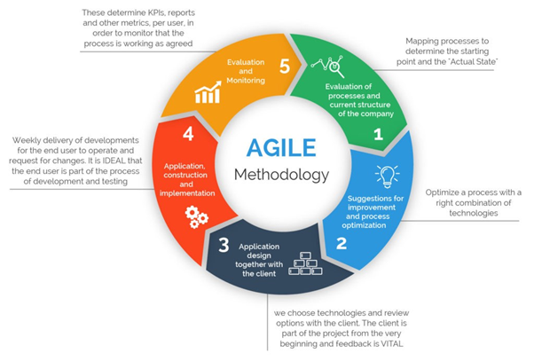

Agile Methodology (Reddy, S., (2019))

SWOT analysis which is a strategic planning technique was used after every sprint

retrospective to identify the strengths, weaknesses, opportunities and threats faced by

our project. This technique helped us in identifying possible strategies in order to

achieve predefined objectives. The method was used especially for improving

processes in the project.

CHALLENGES, LEARNING OUTCOME AND FOLLOWING COMPLEXITIES

The biggest challenges faced during the project development are:

* Technology: understanding and learning new technologies like React-Native and its compatibility & debugging issues. We are coming across various issues with package compatibility or debugging tools, but it is being handled by hard work and various learning tools in order to remove all the negative impact on our development and spend time on troubleshooting. Integrating different components of development in React-Native in the stipulated time frame was complex.
* Project Management Tools: understanding the flow and usage of GitHub and ZenHub was challenging. All the major areas of the project are scheduled on ZenHub. All problems were overcome by following the guidelines given by our co-ordinators, team members and available guidelines which allowed us to be more efficient and proved to be one of the effective ways to share knowledge and reduce time in learning. GitHub and ZenHub used during the process helped not only in learning them but also helped us to stay focussed and finish tasks on time with greater visibility by having the code accessible with all team members at all points of time. Adapting to changes in requirements while minimizing wasted effort.
* Distributed development: due to restrictions on physical meetings availability of all members at one location at one time were solved by having daily meetings and retrospective meetings on every sprint.
* Testing: initially insufficient guidelines for testing but later on we develop a testing strategy that ensures all functions of your application will be examined, run the test under the observation team members, analyse the results and improve your application accordingly.
* Data: CAP theorem helps us to choose the desired database for our project.working with the concepts of NoSQL databases and geo special queries were challenging in nature but working with them gave us a satisfaction of learning new technology and making our application secure, highly available, scalable, performance-oriented and economically feasible.

Feature enhancements, more functionalities for the users and feedback gathered from the user evaluation will be used to develop for the upcoming sprints to make a user-friendly product.

The Gantt chart below illustrates the project timeline which displays the various achieved and planned milestones till completion of project.

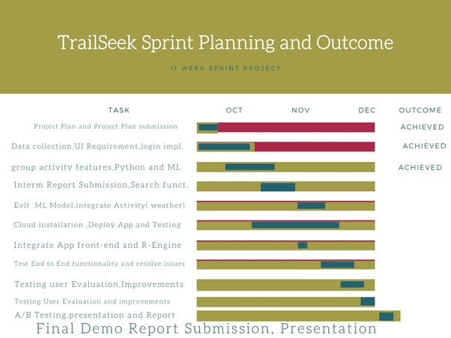

## 6. References and Key Resources

Bohmer, M., Hecht, B., & Schoning, J. (n.d.). Falling asleep with Angry Birds, Facebook and Kindle: A large scale study on mobile application usage. 10.

Charland, A., & Leroux, B. (2011). Mobile application development: Web vs. native. Communications of the ACM, 54(5), 49–53.<https://doi.org/10.1145/1941487.1941504>

Hamonko, M. T., McIntosh, S. E., Schimelpfenig, T., & Leemon, D. (2011). Injuries Related to Hiking with a Pack During National Outdoor Leadership School Courses: A Risk Factor Analysis. Wilderness & Environmental Medicine, 22(1), 2–6.<https://doi.org/10.1016/j.wem.2010.09.010>

Kabali, H. K., Irigoyen, M. M., Nunez-Davis, R., Budacki, J. G., Mohanty, S. H., Leister, K. P., & Bonner, R. L. (2015). Exposure and Use of Mobile Media Devices by Young Children. PEDIATRICS, 136(6), 1044–1050.<https://doi.org/10.1542/peds.2015-2151>

Kelley, H., van Rensburg, T. M., & Jeserich, N. (2016). Determinants of demand for recreational walking trails in Ireland. Tourism Management, 52, 173–186.<https://doi.org/10.1016/j.tourman.2015.05.028>

Larson, L. R., Green, G. T., & Cordell, H. K. (n.d.). Children’s Time Outdoors: Results and Implications of the National Kids Survey. 20.

MacLeod, N. (2017). The role of trails in the creation of tourist space. Journal of Heritage Tourism, 12(5), 423–430.<https://doi.org/10.1080/1743873X.2016.1242590>

Nordbø, I., & Prebensen, N. K. (2015). Hiking as Mental and Physical Experience. In Advances in Hospitality and Leisure (Vol. 11, pp. 169–186). Emerald Group Publishing Limited.<https://doi.org/10.1108/S1745-354220150000011010>

Yablonski, J. (n.d.). Jakob’s Law | Laws of UX. Retrieved October 28, 2020, from<https://lawsofux.com/>

Rieman, J., Franzke, M., & Redmiles, D. (1995, May). Usability evaluation with the cognitive walkthrough. In Conference companion on Human factors in computing systems (pp. 387-388).

Reddy, S., (2019, Feb) Agile Project Management Methodology — Manifesto, Frameworks and Process; from  
 <https://medium.com/@sudarhtc/agile-project-management-methodology-manifesto-frameworks-and-process-f4c332ddb779>

List of resources (software, papers, tutorials, books, stats, business indicators)

Rieman, J., Franzke, M., & Redmiles, D. (1995, May). Usability evaluation with the cognitive walkthrough. In Conference companion on Human factors in computing systems (pp. 387-388).

Agile Project Management Methodology — Manifesto, Frameworks and Process; Sudarsan Reddy; Feb 27, 2019;   
LINK:<https://medium.com/@sudarhtc/agile-project-management-methodology-manifesto-frameworks-and-process-f4c332ddb779>

Porter, P., Yang, S., & Xi, X. (2019). The Design and Implementation of a RESTful IoT Service Using the MERN Stack. 2019 IEEE 16th International Conference on Mobile Ad Hoc and Sensor Systems Workshops (MASSW), 140–145. <https://doi.org/10.1109/massw.2019.00035>

## 